Bird Behavior Classification using YOLOv8

Project Title
Bird Behavior Classification using YOLOv8 Deep Learning Model

Overview
Bird classification and behavior recognition are important tasks in wildlife monitoring, ecological research, and environmental conservation.
This project focuses on building a deep learning-based bird classification system that categorizes birds into three behavioral classes:
- Fly
- Fly_Swim
- No_Fly
The system uses a YOLOv8 classification model trained on a curated bird image dataset. The trained model can also be used for real-time bird behavior detection using a webcam.
The objective of this project is to demonstrate how computer vision and deep learning can be applied to bird monitoring systems.

Dataset
Two datasets were used in this project.
1️⃣ CUB-200-2011 Dataset
The CUB-200-2011 (Caltech-UCSD Birds) dataset is a widely used dataset for bird classification tasks.
Dataset details
- Total Images: ~11,788
- Bird Species: 200
- Image Annotations:
  - Bounding Boxes
  - Class Labels
  - Image IDs
  - Attributes
For this project, the dataset was reorganized into behavioral categories:
- Fly
- Fly_Swim
- No_Fly

2️⃣ Birds Images Dataset
An additional bird image dataset was used to enrich the No_Fly class.
Dataset description
This dataset contains a diverse collection of bird images captured in natural habitats, showing different species, environments, and bird behaviors.
Source: Pixabay
License: Apache 2.0
This dataset includes images such as:
- Owls
- Forest birds
- Ground birds
- Birds resting on trees
These images help improve model generalization for non-flying bird behavior.

Installation
Clone the repository and install the required dependencies.
git clone https://github.com/yourusername/bird-classification-yolov8.git
cd bird-classification-yolov8
Install required libraries:
pip install ultralytics
pip install opencv-python
pip install torch

Usage
1️⃣ Train the Model
python train_model.py
Example training parameters:
- Epochs: 20 / 32 / 64
- Image Size: 224
- Batch Size: 16

2️⃣ Run Camera Demo
python camera_test.py
This will open a webcam window and classify bird behavior in real time.
Example output:
Bird Category: Fly
Bird Category: Fly_Swim
Bird Category: No_Fly

Methodology
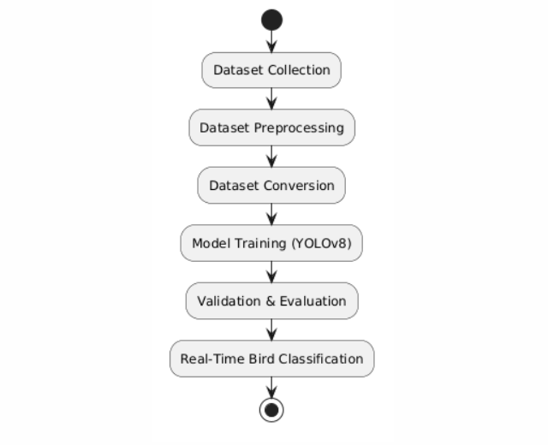Key Steps
- Dataset collection from multiple sources
- Data cleaning and filtering
- Dataset conversion to YOLOv8 classification format
- Model training using YOLOv8
- Validation using unseen images
- Real-time inference using webcam

Models Used
The following deep learning model was used:
YOLOv8 Classification Model
Framework: Ultralytics YOLOv8
Advantages:
- Fast training
- High accuracy
- Efficient real-time inference
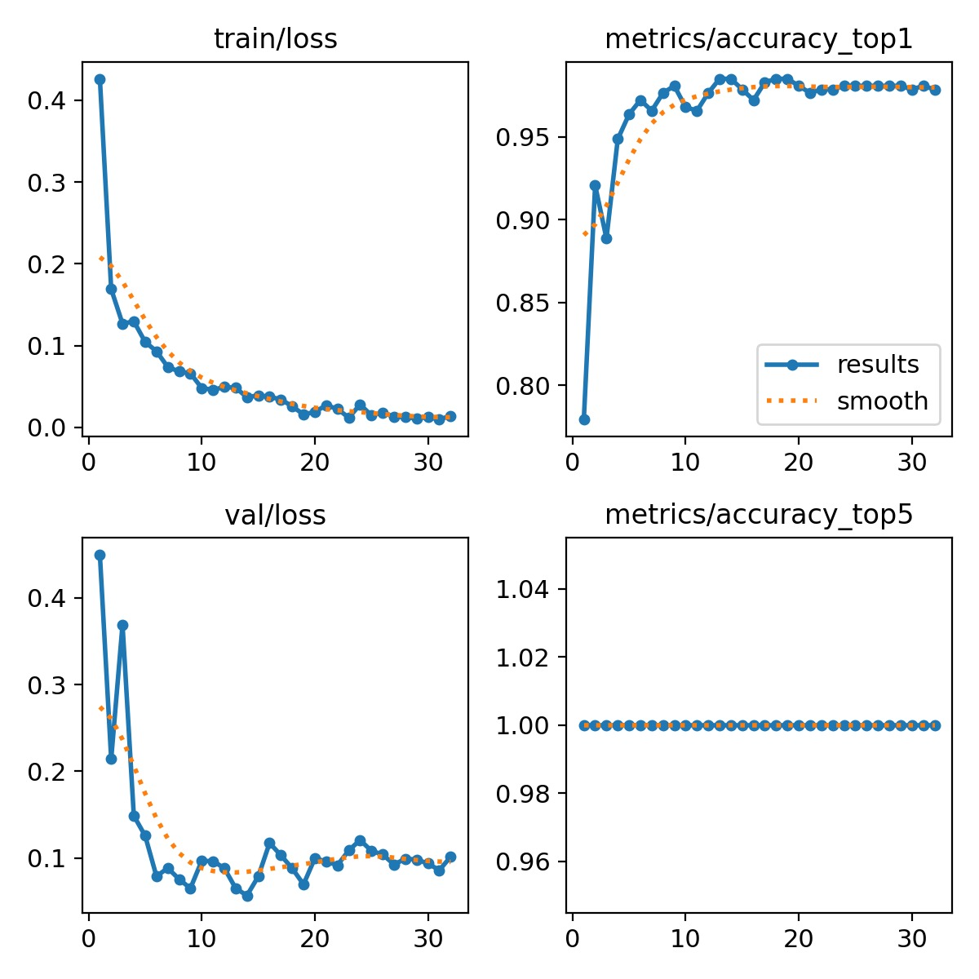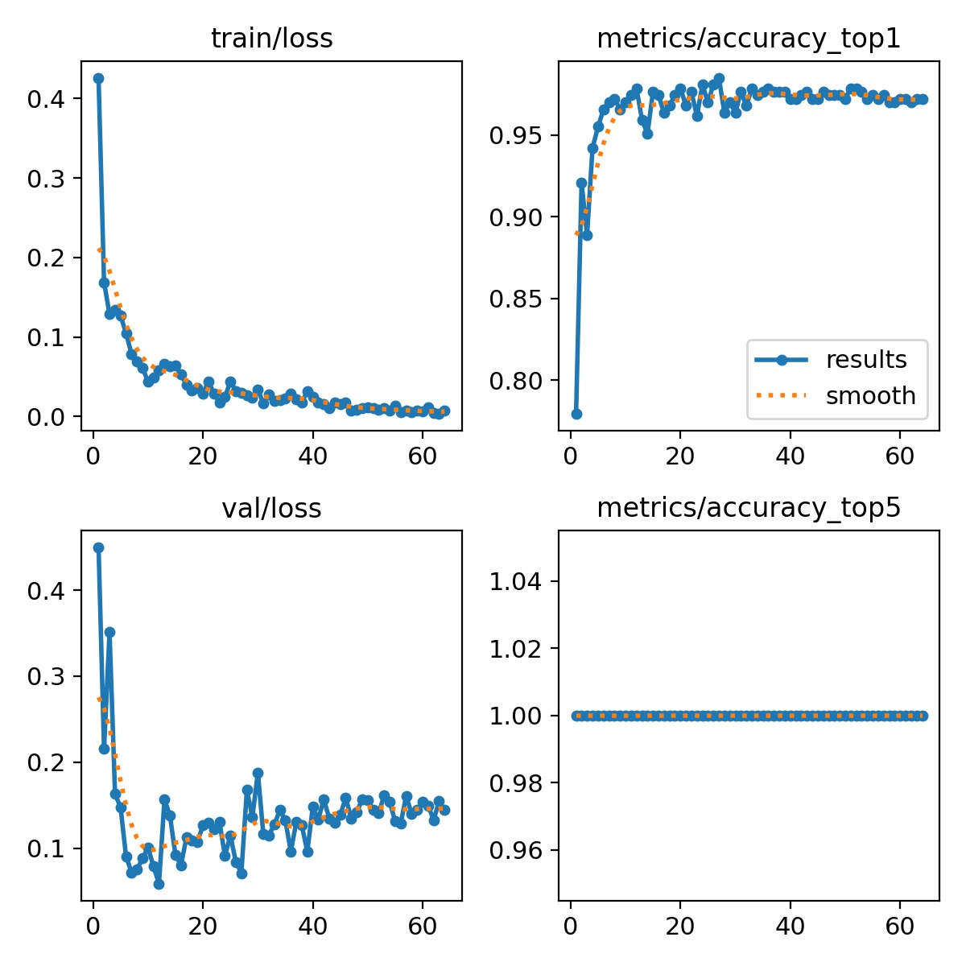
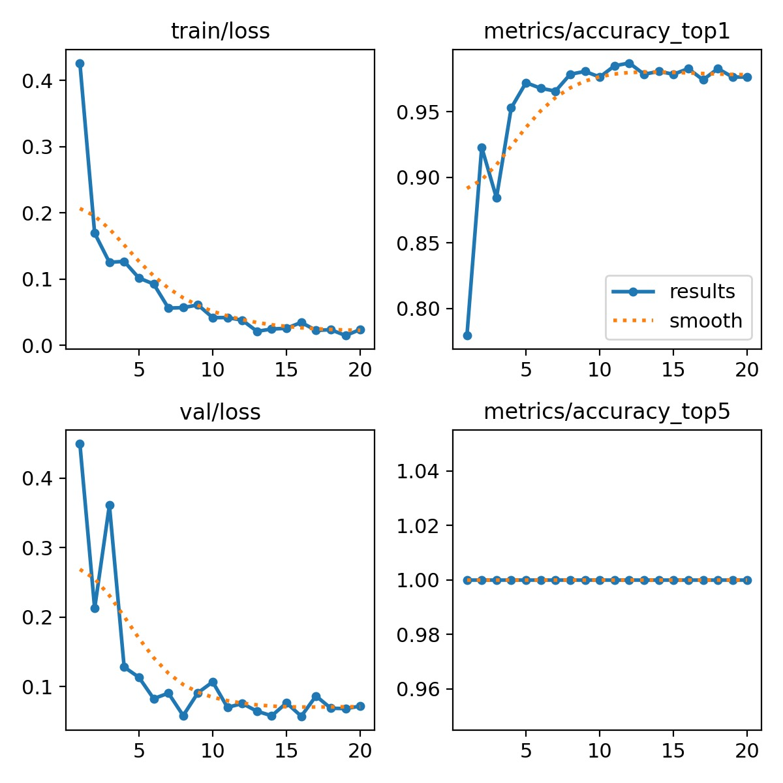

Model configuration:
Parameter | Value
Model | YOLOv8n-cls
Epochs | 20 / 32 / 64
Image Size | 224
Optimizer | AdamW
Framework | PyTorch

Results
The model achieved strong performance on the validation dataset.
Metric | Value
Top-1 Accuracy | 0.985
Top-5 Accuracy | 1.0
Validation Images | 467
Training Images | 1501
Key Observations
- Training loss decreased steadily.
- Validation accuracy stabilized after ~20 epochs.
- Increasing epochs improved stability but gave minor accuracy gains.
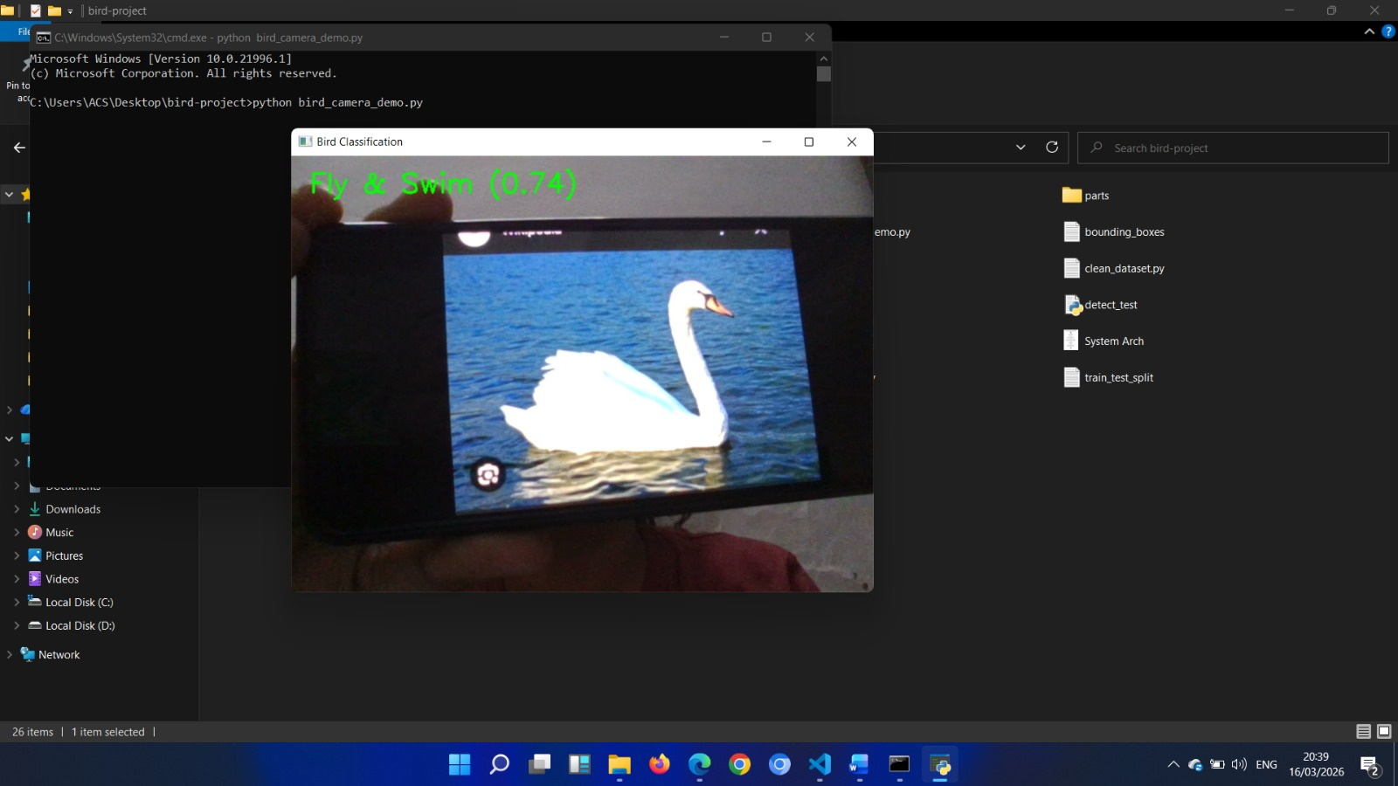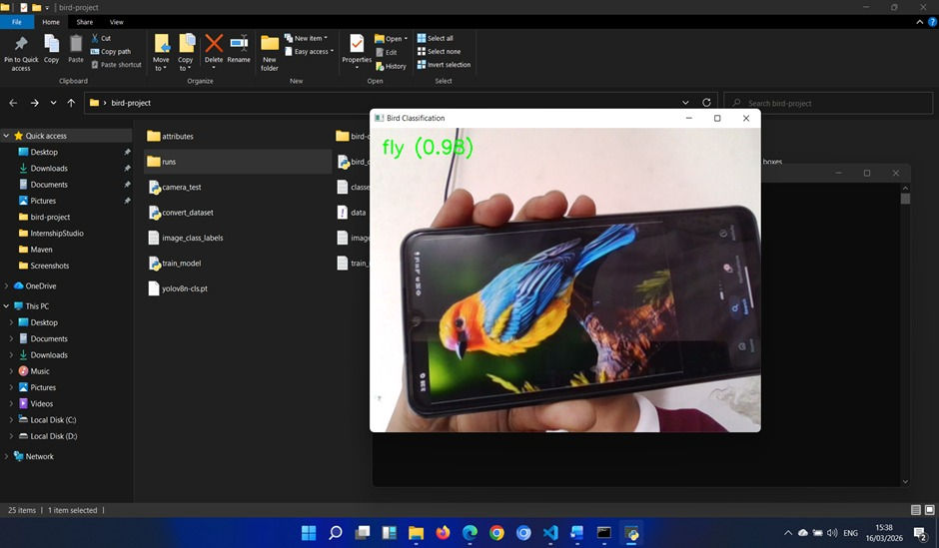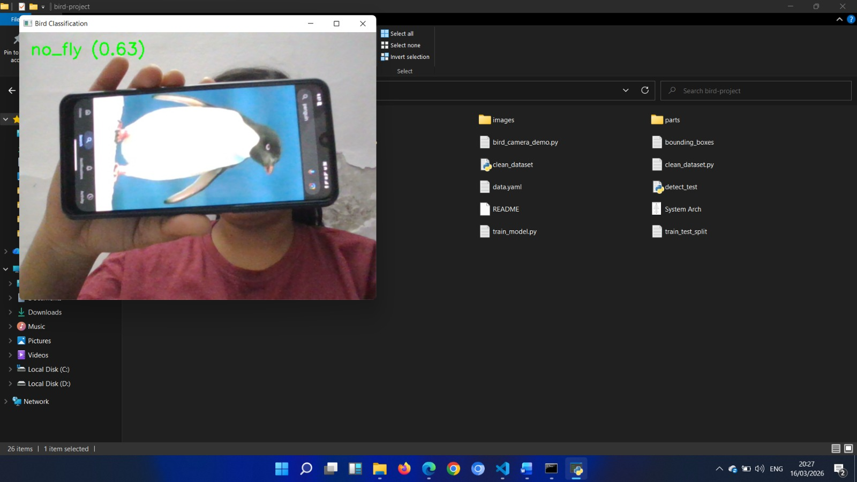

Visualizations
Training generated multiple visualizations:
Training Metrics
- Train Loss Curve
- Validation Loss Curve
- Top-1 Accuracy
- Top-5 Accuracy
These graphs help analyze:
- Model learning progression
- Overfitting behavior
- Accuracy improvements across epochs
Example visualization:
Epoch vs Loss
Epoch vs Accuracy
These plots are automatically generated inside:
runs/classify/train/

Kaggle Submission
This project can be submitted on Kaggle as:
Computer Vision Classification Project
Submission includes:
- Trained YOLOv8 model
- Training scripts
- Dataset preprocessing code
- Performance metrics
- Visualizations

Project Structure
bird-project
│
├── bird-dataset
│ ├── train
│ │ ├── fly
│ │ ├── fly_swim
│ │ └── no_fly
│ │
│ └── val
│ ├── fly
│ ├── fly_swim
│ └── no_fly
│
├── convert_dataset.py
├── train_model.py
├── camera_test.py
├── detect_test.py
│
├── runs
│ └── classify
│
└── README.md

Future Work
Several improvements can enhance this project:
- Add more bird behavior categories
- Use larger bird datasets
- Train with YOLOv8m or YOLOv8l models
- Deploy model on mobile or edge devices
- Integrate object detection + classification
- Build a web-based bird monitoring system

Contributing
Contributions are welcome!
You can contribute by:
- Improving dataset quality
- Adding new bird categories
- Optimizing model performance
- Enhancing documentation
Please submit a pull request for improvements.

License
This project is licensed under the Apache 2.0 License.

Acknowledgements
Special thanks to:
- The Ultralytics YOLOv8 team
- PyTorch developers
- Pixabay for bird images
- CUB-200-2011 dataset creators
- Kaggle community for open datasets

